Falcon Drama 2022-2023
Friday Sept 2 at 3:30pm in room 185: Drama Mixer
Tuesday Sept 6-Friday Sept 9: Footloose! Auditions
Monday Sept 12 at 7pm: Footloose! Parent Meeting
Friday Sept 16: Cappies Critic Application due to Miss G
Friday Sept 23: SP Cares audition forms & music due
Thursday Sept 29 at 6pm: Tech for SP Cares
Friday Sept 30 at 7pm: SP Cares
Monday Oct 3 during Falcon Block: Thespian Meeting
Friday Oct 7: One Act Director Applications & scripts due to Miss G
Friday Oct 28 at 7pm in rm 185: Improv Night
November 4-6, 11-12: Footloose!
Monday November 7 during Falcon Block: Thespian Meeting
Monday Nov 7 at 3:30pm: One Act Auditions
Friday Nov 18: RnR Student Leader application/video due to Miss G
Mon Nov 28 at 3:30pm in cafeteria: Rock’n’Roll Revival Mtg
Tues Nov 29-Friday Dec 16: RnR Revival Auditions
Monday Dec 5 during Falcon Block: Thespian Meeting
Mon Dec 5 at 7pm Booster Meeting
Friday Dec 16 at 7pm in rm 185: Improv Night
Mon Jan 2 during Falcon Block: Thespian Meeting
Mon Jan 2 at 3:30pm in auditorium: RnR Meeting
Mon Jan 2 at 7pm: RnR Parent Meeting
Thurs Jan 5 at 6pm in Auditorium: Tech Night for One Acts
Fri Jan 6 at 7pm: One Act Play Night
Mon Feb 6 during Falcon Block:Thespian Meeting
Mon March 6 during Falcon Block: Thespian Meeting
March 9-12, 16-18: RnR Revival XXXIV
Friday March 24 at 7pm in rm 185: Improv Night
April 1: Thespian Applications due to Miss G
April 3 during Falcon Block: Thespian Meeting
May 1 during Falcon Block: Thespian Meeting
Fri May 5: SP Cares application/music due
Friday May 12 at 7pm in rm 185: Improv Night
Thurs May 25 at 6pm: Tech for SP Cares
Fri May 26 at 7pm: SP Cares
Mon June 5 during Falcon Block: Thespian Meeting
Monday June 5 at 7pm Booster Meeting
Auditions: Sept 6-9
Show dates: Nov 4-6, 11-12

ONE ACTS
Director Application due Oct 7
Auditions Mon Nov 7 at 3:30pm in rm 185
One Act Play Night Friday Jan 6 at 7pm

ROCK’N’ROLL REVIVAL XXXIV: AT THE MOVIES!
Student Leader application/video due Fri Nov 18
Organizational Meeting: Monday Nov 28 at 3:30 in Cafeteria
Auditions: Nov 29-Dec 16
Show Dates: March 9-12, 16-18

JOIN THE CAPPIES!
Applications due: Friday Sept 16
The Cappies (Critics and Awards Program) is an international program which was launched in FCPS. It recognizes, celebrates, and provides learning experiences for high school theater and journalism students, and teenage playwrights.
www.sphsdrama.com

INTERNATIONAL THESPIAN TROUP #2476
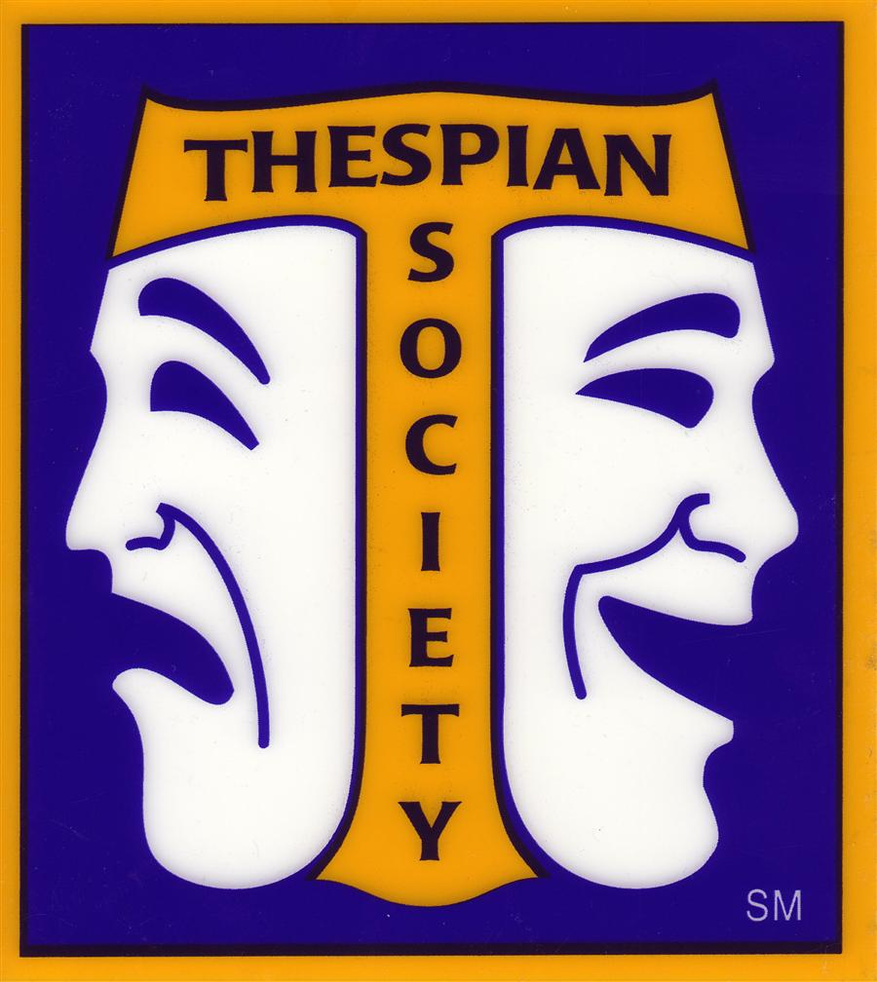
Meetings are the first Monday of each month during Falcon Block- all are welcome!
IMPROV TROUPE!
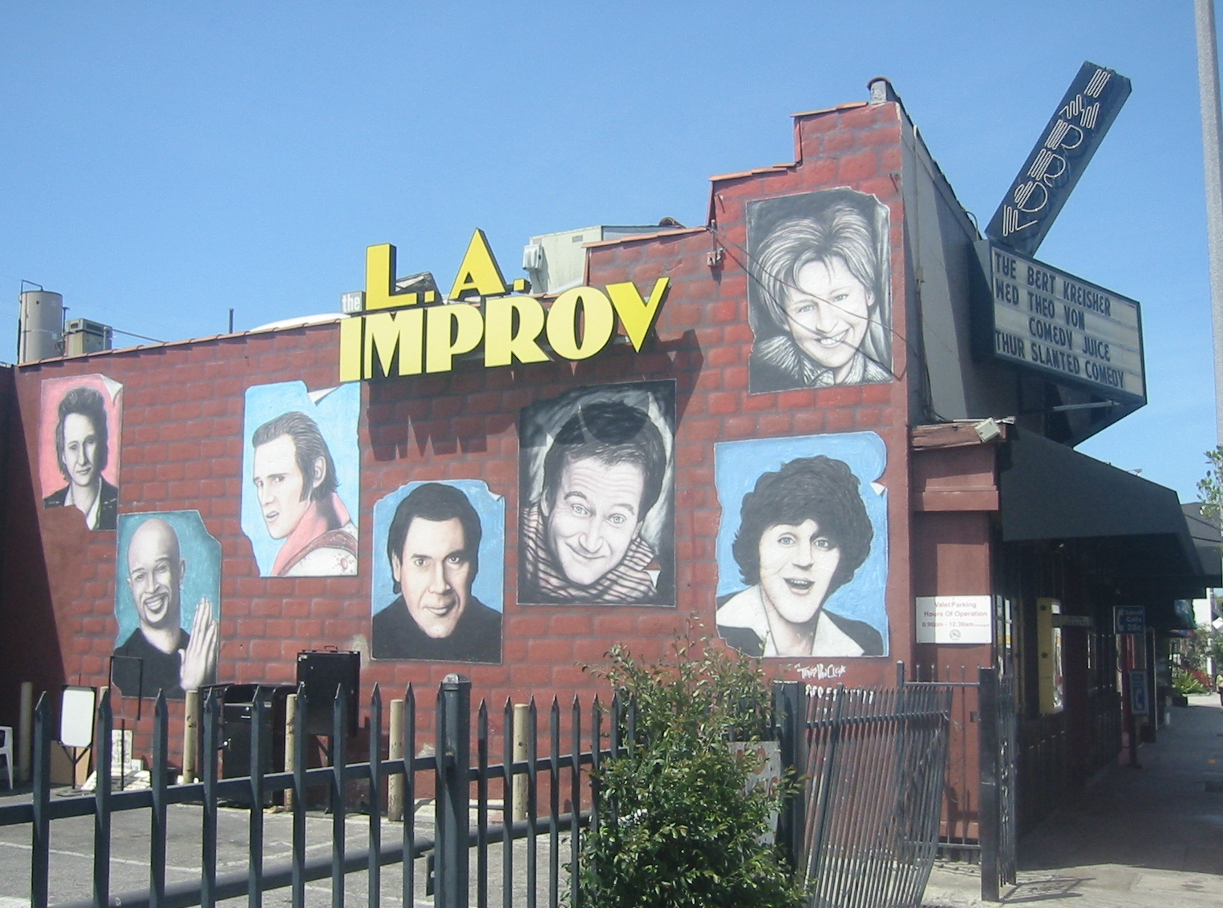
Practices are every Tuesday & Thursday during Falcon Block and after school 3:30-5pm in rm 185

SHOWS are Oct 28, Dec 16, Mar 24 & May 12 at 7pm in rm 185 ADMISSION IS FREE!

